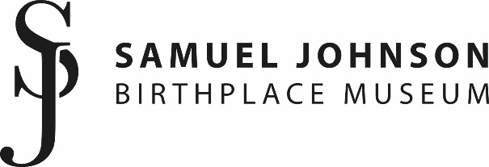

Volunteer Application

Thank you so much for your interest in volunteering at the Samuel Johnson Birthplace Museum. Please take a few minutes to complete the below form so we can learn a bit more about you.
If you have any questions about completing this form or about your volunteer application, please contact sjmuseum@lichfield.gov.uk
Please indicate which role/s you’re interested in… (tick all that apply)
Volunteer Role: Collections
Volunteer Role: Collections Inventory
Volunteer Role: Sewing

Your details:
Name
Address

Email address
Contact number
Over 18?

A bit more about you:
What interests you most about volunteering at the Samuel Johnson Birthplace Museum?

With your preferred role in mind, please tell us about any relevant experience you have:
(feel free to attach a CV if you’d like, but it’s not a necessity)

Please tell us about your hobbies, interests or special skills relevant to volunteering here:

Are there any health concerns that you may need support with?

This role will require a DBS check. Do you have any objection to this?

Please supply the name and email address of one referee who knows you well, and please explain your relationship to them:

How did you hear about volunteering opportunities at the Samuel Johnson Birthplace Museum?

Please tell us about your availability and how much time you would like to volunteer: (Please refer to role descriptions for minimum time requirements.)

Please return completed applications to sjmuseum@licfield.gov.uk
Thank you.

